Border Children Teach-In—August 5, 2014—Evaluation responses

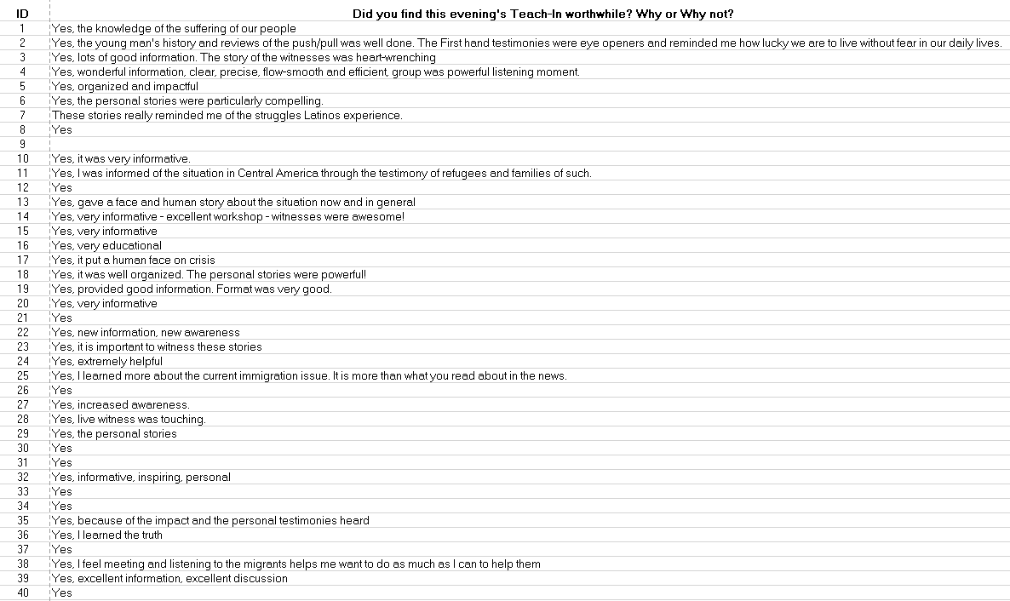

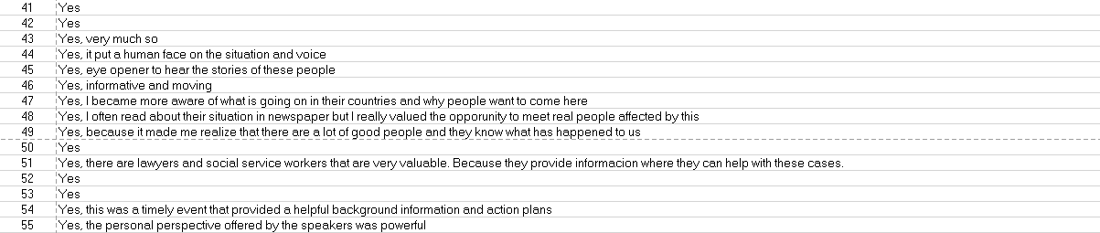

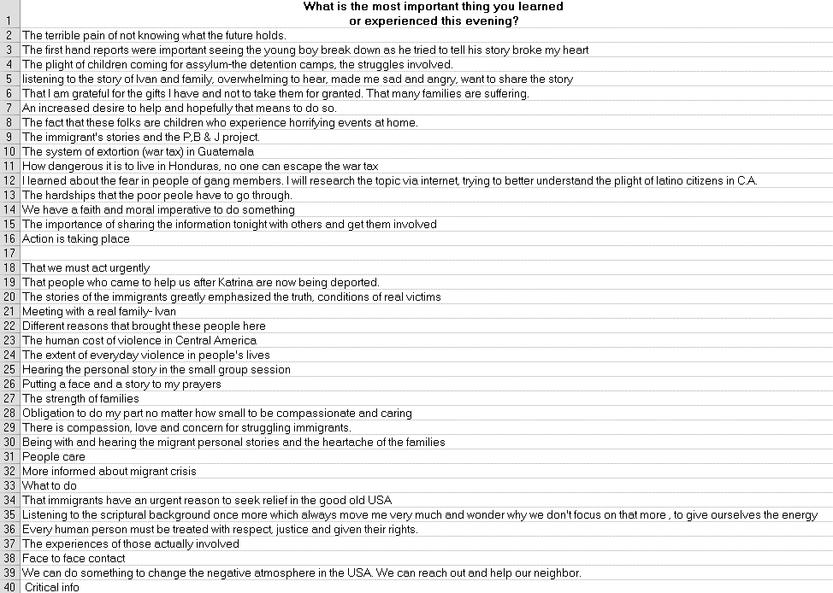

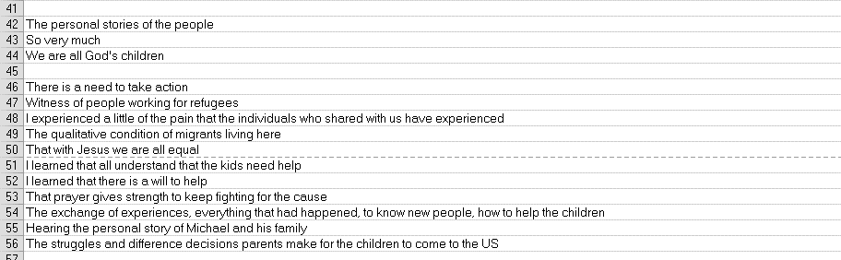

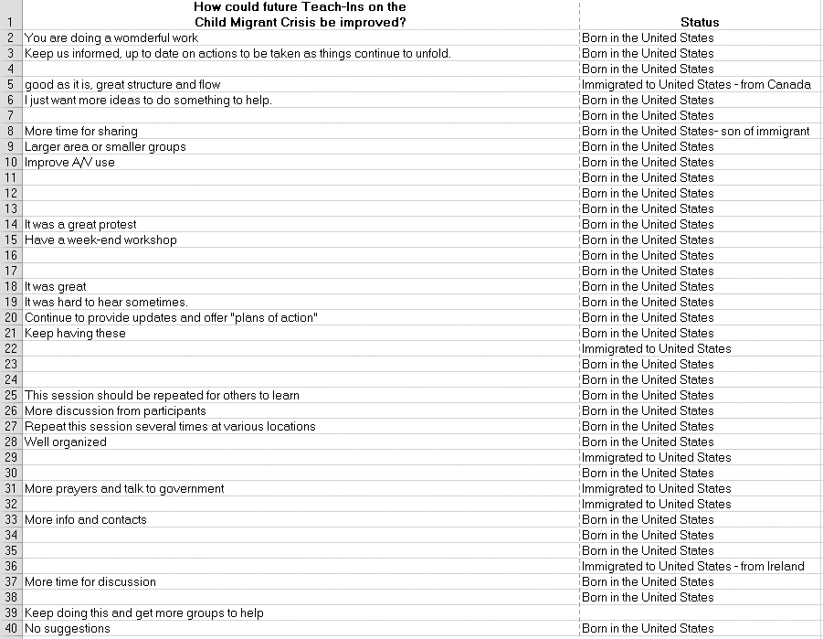

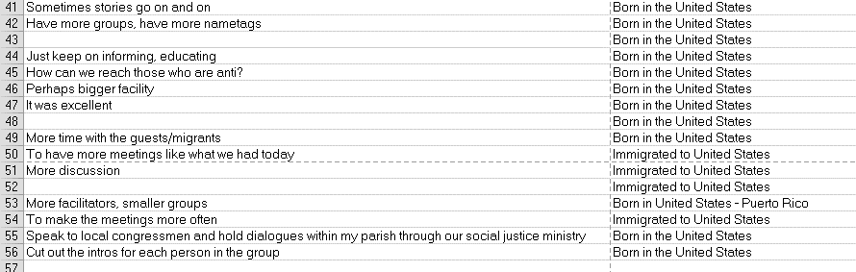

Evaluations of August 5, 2014 of Border Children Teach-In held at St. Anthony of Padua Church hall.